Print First 5 Rows of StockPrices After Calculating Returns

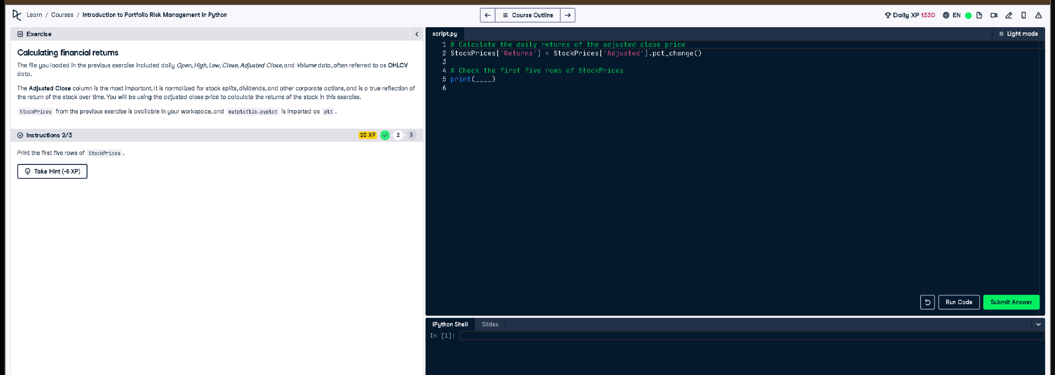

# Python Code

# Calculate the daily returns of the adjusted close price  
StockPrices['Returns'] = StockPrices['Adjusted'].pct_change()  
  
# Check the first five rows of StockPrices  
print(StockPrices.head())

# Explanation (in simple words)

This code first calculates daily returns using the percentage change in the 'Adjusted' column. Then it prints the first five rows of the StockPrices DataFrame using .head(). This helps check that the 'Returns' column was added correctly and the data looks as expected.